LAB-CROSS SITE SCRIPTING

Objectives

In this lab, is to perform Reflected XSS and Stored XSS attacks against the DVWA (Damn Vulnerable Web Application!) at low, medium, and high security levels.

Part 1: Perform Reflective Cross Site Scripting Exploits
Part 2: Perform Stored Cross Site Scripting Exploits

Background / Scenario
In this lab, I will perform penetration tests of a web application to determine if it has been securely designed.
DVWA (Damn Vulnerable Web Application!) is a PHP/MySQL web application. It is designed to be vulnerable to common attacks to allow security professionals to test their skills and tools and students and teachers to learn and understand web application security in a legal environment.
DVWA provides four levels of security: Low, Medium, High, and Impossible. Each security level requires different skills to perform exploits. The security levels reflect different levels of security that developers may code into their applications. In this lab, you will perform exploits against three of the security levels, Low, Medium, and High, allowing you to adjust your attacks to compromise them.

Required Resources
Kali VM customized for the Ethical Hacker course
Internet access

Part 1: Perform Reflective Cross Site Scripting Exploits
A Reflected XSS attack is one in which a malicious script is reflected off a web server to the user's browser. The script is activated through a link that the victim clicks. This will send a request to the website that has a vulnerability that enables execution of the malicious script.
Step 1: Log into DVWA.

- From the Kali Linux VM (from cisco), open a browser and navigate to the DVWA application.
- Enter the following URL into the browser http://10.6.6.13.
- At the login prompt, enter the credentials: admin/password.

Step 2: Perform a Reflected XSS attack at Low security level.
- Select DVWA Security in the left menu and select Low in the Security Level dropdown. Click Submit.
- Select XSS (Reflected) from the left menu.
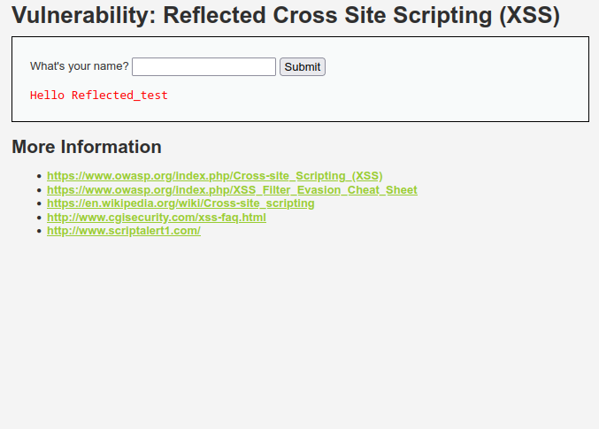
- Type the string Reflected_Test in the What's your name? box and click Submit.

- Enter CTRL+U on the keyboard to view the source code of the page.
- Search for the string Hello Reflected_Test by entering CTRL+F to open a search box.

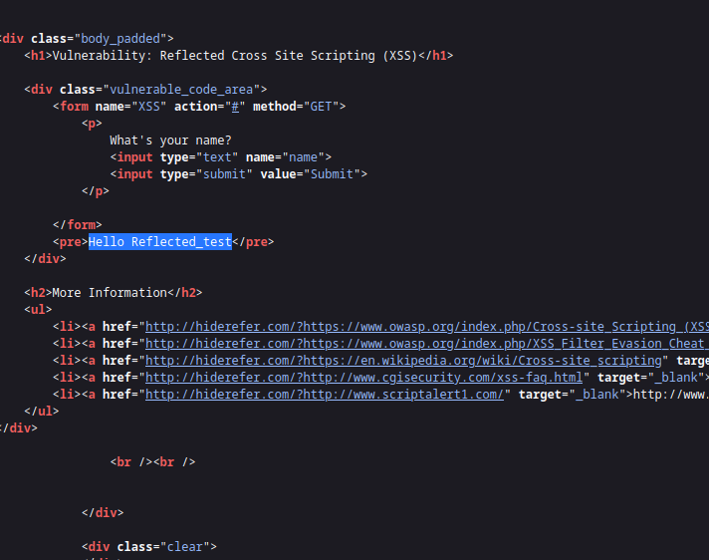

The presence of the string in the page source HTML indicates that values entered in a user response text field are inserted into the source code for the page. This indicates to an attacker that the page may be vulnerable to reflected XSS attacks.
- Close the source code window and return to the Reflected XSS Vulnerability page.
- Enter the following payload in the What’s your name? box and click Submit.
<script>alert("You are hacked!")</script>
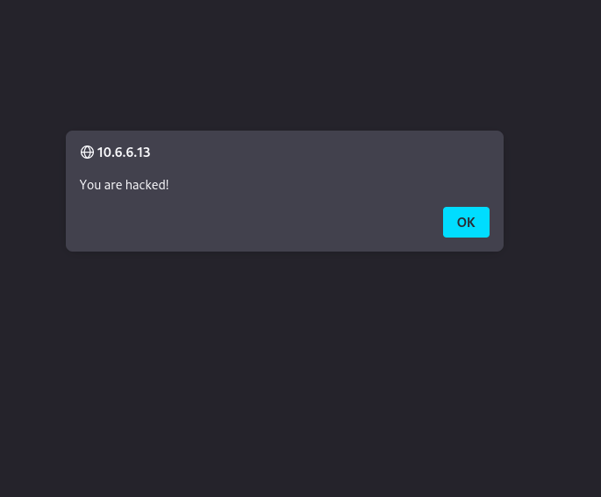

An alert popup box will appear with the words You are hacked! This means the site is vulnerable to Reflected XSS attacks and we have successfully exploited the vulnerability.

- Select and copy the URL for the compromised page. Open a new browser tab and paste the URL into the URL field and press <Enter>.

You should see the same web page appear displaying the You are hacked! popup box. This means that if a user opens the URL a malicious script will execute. The alert box is used to simulate a malicious script in this lab.

Step 3: Perform a Reflected XSS attack at medium security level.
You will attempt the same attack, but this time the security level of the Web site will Medium.
- Select DVWA Security in the left menu and select Medium in the Security Level dropdown. Click Submit.
- Select XSS (Reflected) in the left menu.
- Again, enter the following payload in the What's your name? box and click Submit.
<script>alert ("You are hacked!") </script>
You will see a Hello response, but this time no pop up will appear. This indicates that the script did not execute. Note that the script is displayed as literal text.
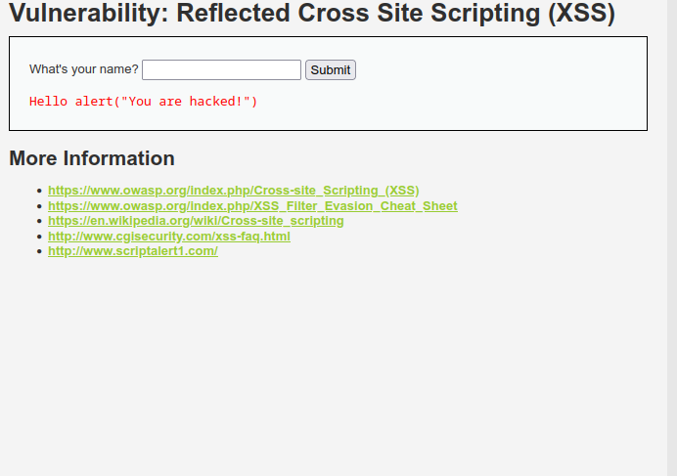

We can analyze the code in the backend of the web site to investigate the reason.
- Click the View Source button on the bottom right of the page and review the PHP code.

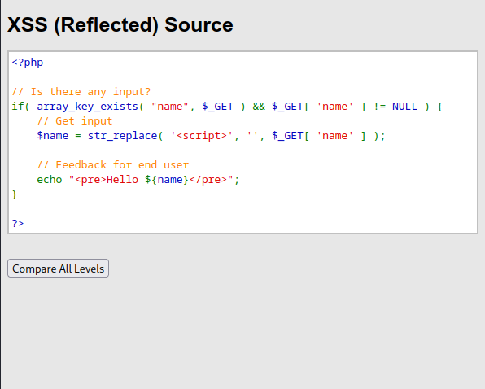

Note: On a real web server, we would not have access to this backend source code, but here on DVWS we do.
- Note the line:
$name = str_replace ( '<script>', '', $_GET[ 'name' ] );
This source code creates a filter, with str_replace() function, that removes the <script> tag in our payload and replaces it with a null value. This renders the payload script ineffective, so the attack failed, and no popup window is displayed. Because this script is only filtering out <script> in lower case, we can try and get around the filter by using a different tag in the payload. We will use <ScRipt>.

- Close the source code window and return to the Reflected XSS Vulnerability page.
- Enter the following payload in the What's your name? box and click Submit.
<ScRipt>alert("You are hacked!")</ScRipt>
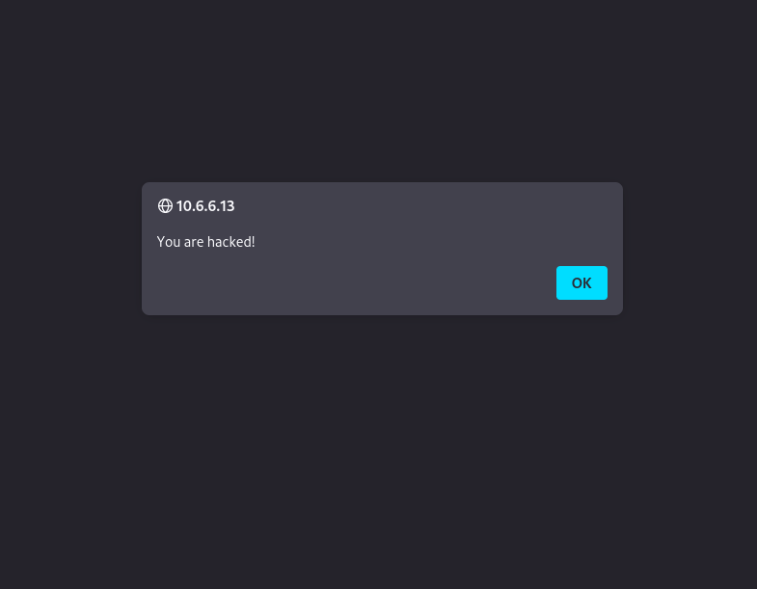

Step 4: Perform a Reflective XSS attack at High security level.
The same attack will be attempted, but this time the security level of the website will be High.
- Select DVWA Security in the left menu and select High in the Security Level dropdown. Click Submit.
- Select XSS (Reflected) in the left menu.
- Enter the following payload in the What's your name? box and click Submit. (Note the use of underscores to replace spaces.)
<ScRipt>alert("You_are_hacked!")</ScRipt>

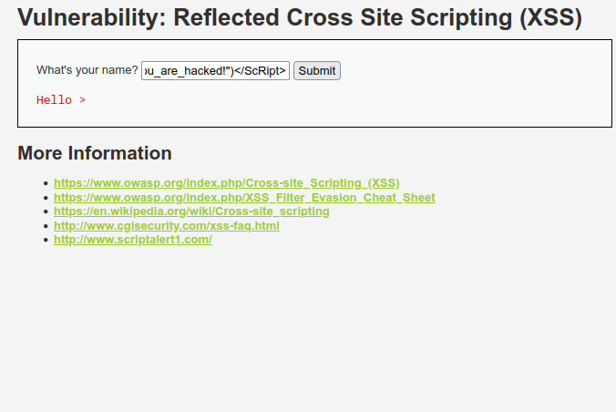

There is a Hello message and no alert pop up box. Again, we can analyze the backend source code to investigate.
- Click the View Source button and review the PHP code.
Note the following line:
$name = preg_replace( '/<(.*)s(.*)c(.*)r(.*)i(.*)p(.*)t/i', '', $_GET[ 'name' ] );
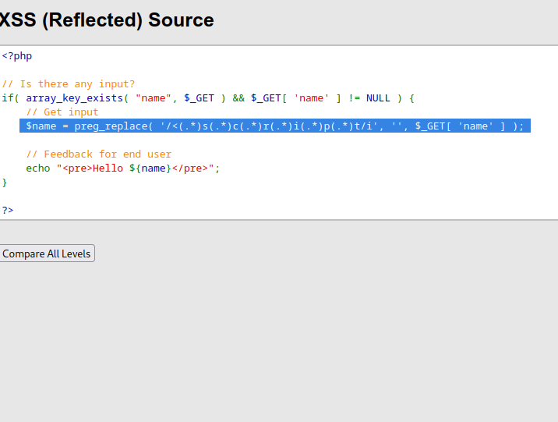

In this code, the developer used a regular expression to replace any form of the <script> tag, no matter what case of the characters is used, with a null value.
- To bypass this filter, we must use another HTML tag instead of <script> to attack the site.
- Close the source code window and return to the Reflected XSS Vulnerability page.
- Enter the following payload in the What's your name? box and click Submit. (Note the use of underscores to replace spaces.)
<img src=x onerror=alert("You_are_hacked!")>
The XSS popup box will appear this time. We successfully bypassed the filter and exploited the Reflected XSS vulnerability in DVWA at High level security.
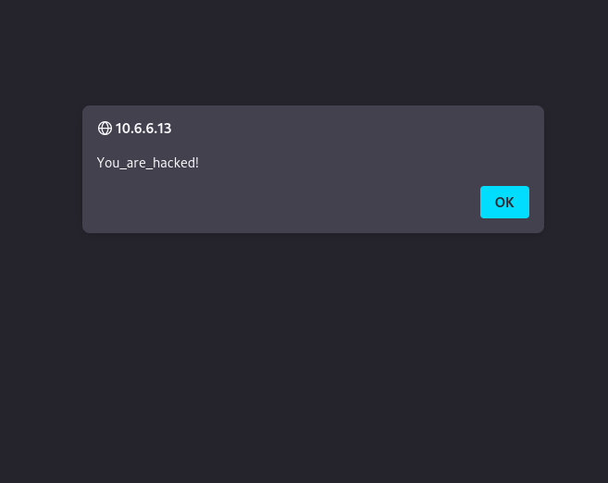

Part 2: Perform Stored Cross Site Scripting Exploits
With the stored XSS exploit, you enter a malicious script through user input and the script is stored on the target server in a message forum, database, visitor log, or comment field. When a user visits the target, the server exposes the user to the malicious code.

Step 1: Perform a Stored XSS attack at Low security level.
Exploiting stored XSS at low level security is easy because there are no security measures in place. You can simply submit a <script> to achieve the exploit.
- Select DVWA Security in the left menu and select Low in the Security Level dropdown. Click Submit.
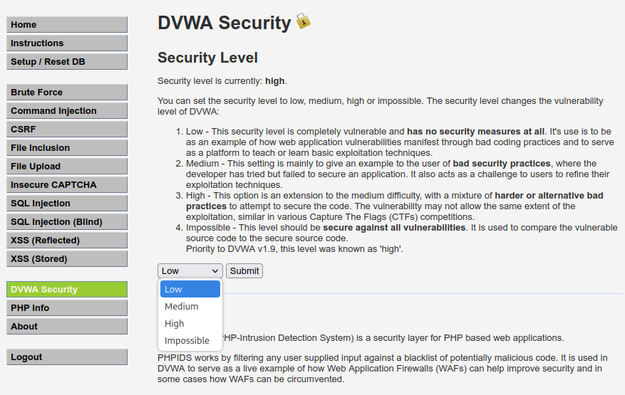
- Select XSS (Stored) in the left menu.
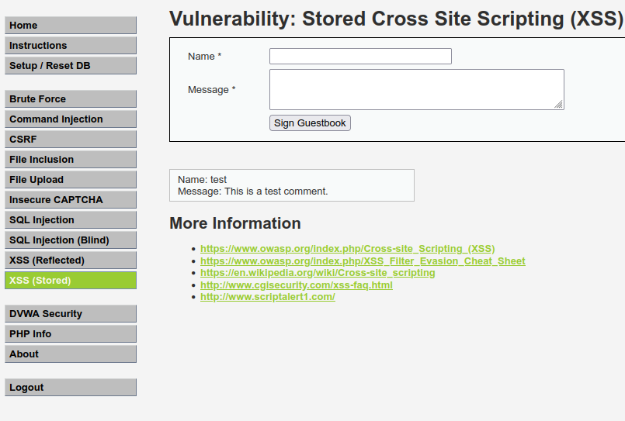

- Type the string XSS Test#1 in the Name* field and type Stored XSS Test in the Message * field. click Sign Guestbook.

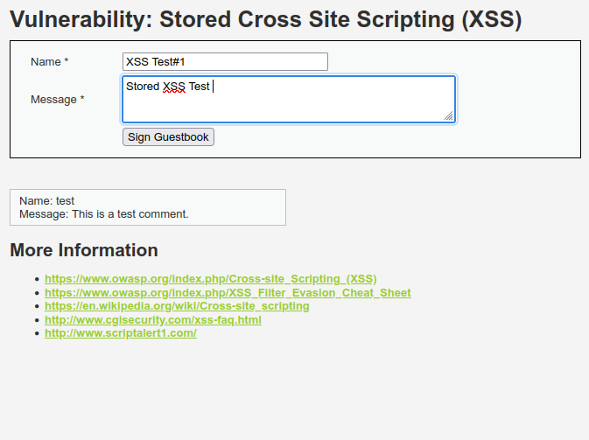

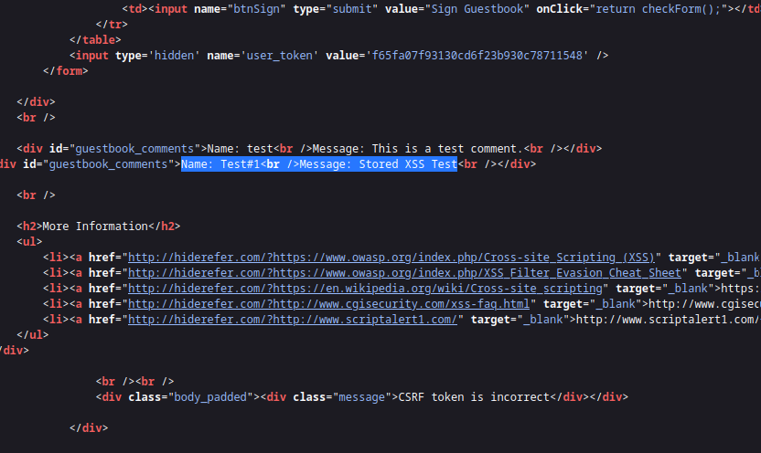
- Enter CTRL+U on the keyboard to view the page source code. Enter CTRL+F to search for the Test#1 and Stored XSS Test strings.

Both strings, Test#1 and Stored XSS Test, will be in the page source code indicating that the two input fields may be vulnerable to a Stored XSS attack.
- Close the source code window and return to the Stored XSS Vulnerability page.
- Enter Test#1 in the Name * box and enter the following payload in the Message * field and click Sign Guestbook.
<script>alert("You are hacked!")</script>
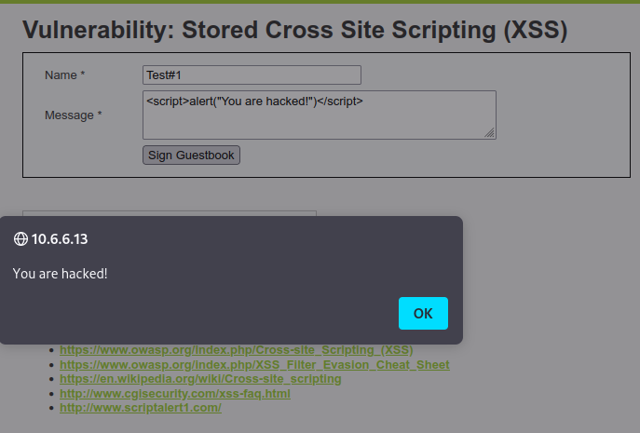

An XSS alert popup box will appear with the words You are hacked! This means the site was vulnerable to stored XSS attacks and we have successfully exploited the vulnerability.
- Refresh the page. If alerted, click Resend to display the page. The XSS alert popup box will appear again.
Because the XSS payload is stored in the guestbook, the alert popup box will appear each time the page is refreshed.
- Before proceeding to the next step, clear the XSS payload from the page. Click Setup / Reset DB in the left menu then click Create / Reset Database.

Step 2: Perform a Stored XSS attack at medium security level.
Exploiting reflected XSS at medium level security is not difficult. Using <script> will be rejected but changing it to a different case such as <ScRipt> will bypass the security and achieve the exploit.
- Select DVWA Security in the left menu and select Medium in the Security Level options dropdown. Click Submit.
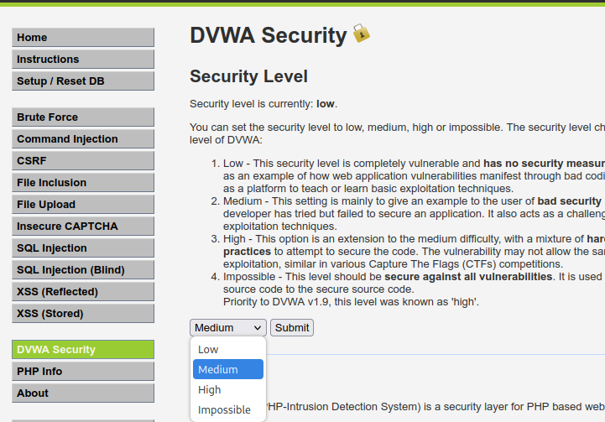

- Select XSS (Stored) in the left menu.
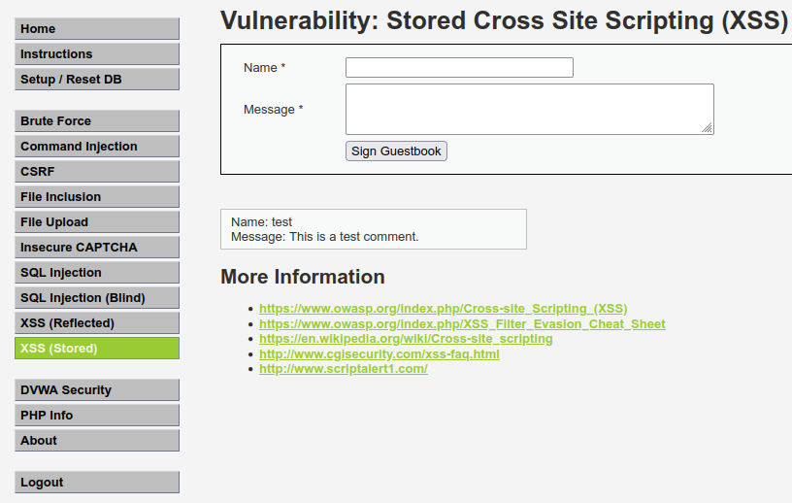

- Type the string XSS Test#1 in the Name* field and type Stored XSS Test in the Message * field. click Sign Guestbook.

- Enter CTRL+U on the keyboard to view the page source code. Enter CTRL+F to search for the Test#1 and Stored XSS Test strings.
Both strings will be in the page source code indicating that the two input fields may be vulnerable to a Stored XSS attack.
- Close the source code window and return to the Vulnerability page.
- Enter Test#1 in the Name * box and enter the following payload in the Message * box and click Sign Guestbook.
<script>alert("You are hacked!")</script>
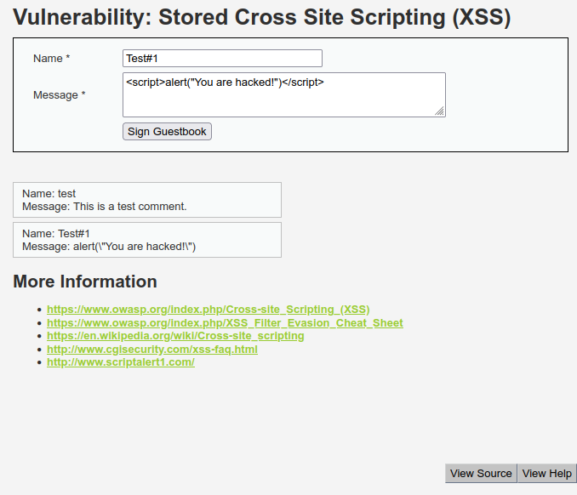

No popup box should appear. Refreshing the page should not cause the alert popup box to appear either.

This means that there is code in the backend that is sanitizing the user input from the Message * field to prevent scripts from being submitted. You can see the modified input in the last rectangle message box below the input fields.
- Click the View Source button and review the PHP source code and investigate.

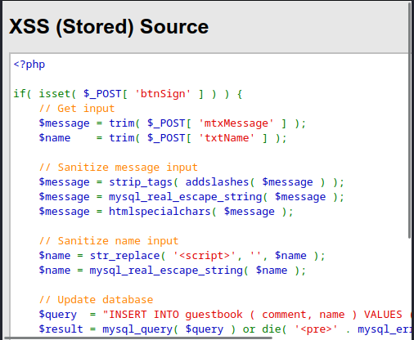

The first block of code, under // Sanitize message input, contains two PHP functions for performing input sanitization. The strip_tags() function removes all html tags from the message field before storing them in the database. The htmlspecialchars() function converts all special characters into equivalent HTML entities so they are not reflected back in the browser

The second block of code, under // Sanitize name input, performs input sanitation on the Name * field. It contains the str_replace() function which replaces any occurrence of the <script> tag with a null value. This disables the script completely.

We can attempt to bypass the security on the Name * field by using some other payload that does not contain <script> tags.
- Close the source code window.
- Before entering any payload into the Name * field, the max character length restriction of 10 characters on the field must be increased. This is a client-side setting so it is easy to change with the following steps:

- Right-click in the Name * field and select Inspect. This opens the Web Developer Tools window and displays the page source code.
- Find and double-click maxlength in the page source and change it from 10 to 100. The maxlength property is inside the <input> tag for the text field.

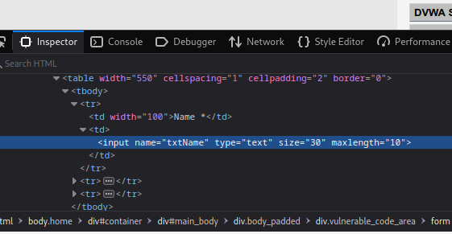

- Press Enter on the keyboard to apply the changes.
- Close the Web Developer’s Tools Window.
With the maxlength restriction changed, the XSS payload can now be entered into the Name * field.
Note: Changing the maxlength parameter does not persist. If you refresh the page, for example, the setting needs to be changed again.
- Return to the Vulnerability page and enter the following payload in the Name * field.
<ScRipt>alert("You are hacked!")</ScRipt>
- In the Message * field you can type any text you like and then click Sign Guestbook.

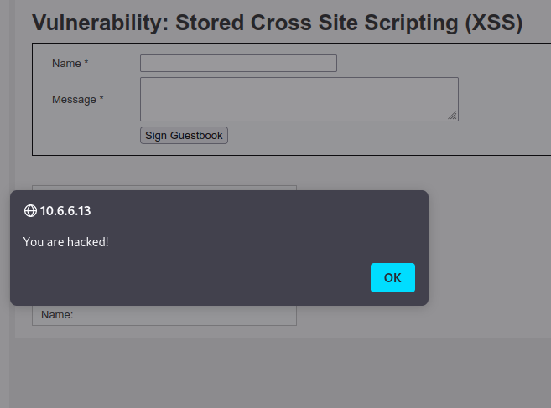

An XSS alert popup box will appear with the words You are hacked!.
Because the XSS payload is stored in the guestbook, the alert popup box will appear each time the page is refreshed or each time other users visit the page.
The popup confirms you have successfully exploited Stored XSS vulnerability at the Medium level of security.
- Before proceeding to the next step, clear the XSS payload from the page. Click Setup / Reset DB in the left menu then click Create / Reset Database.
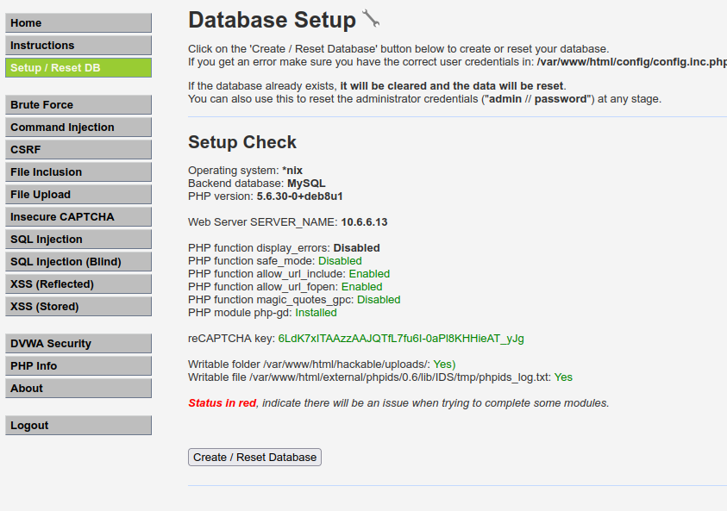

Step 3: Perform a Stored XSS attack at High security level.
- Select DVWA Security in the left menu and select High in the Security Level dropdown. Click Submit.
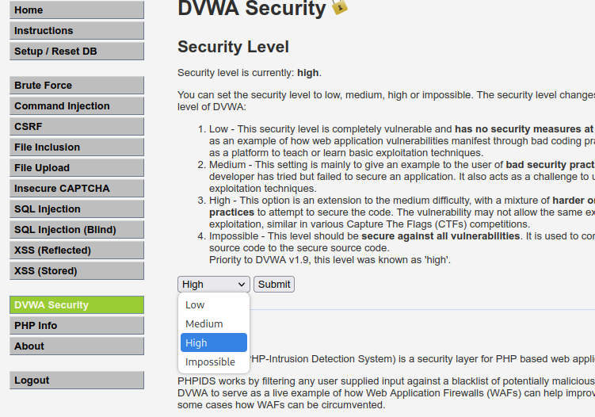

- Select XSS (Stored) in the left menu.
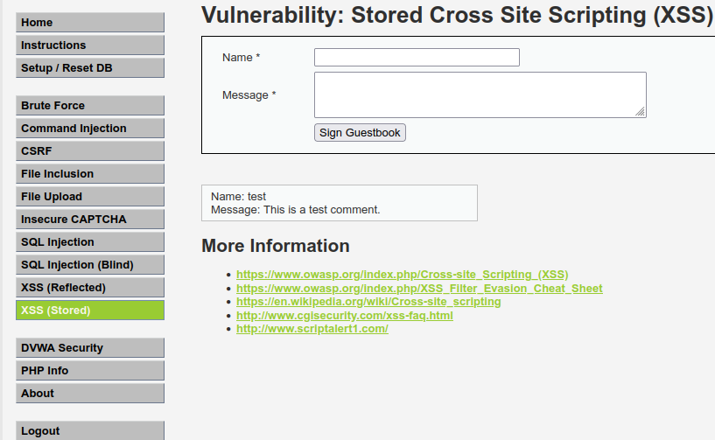

- Type the string Test#1 in the Name* field and type Stored XSS Test in the Message * field. Click Sign Guestbook.
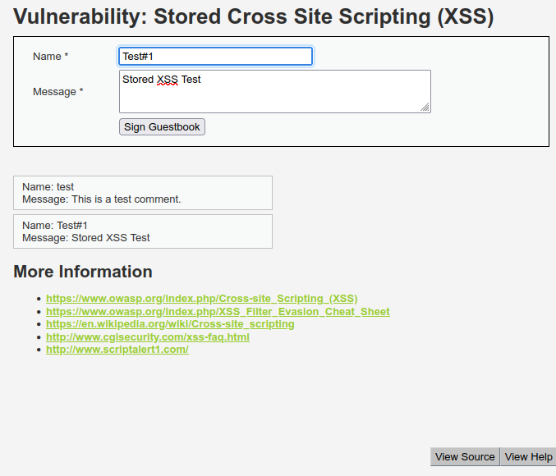

- Enter CTRL+U on the keyboard to view the page source code. Enter CTRL+F to search for the Test#1 and XSS Test strings.
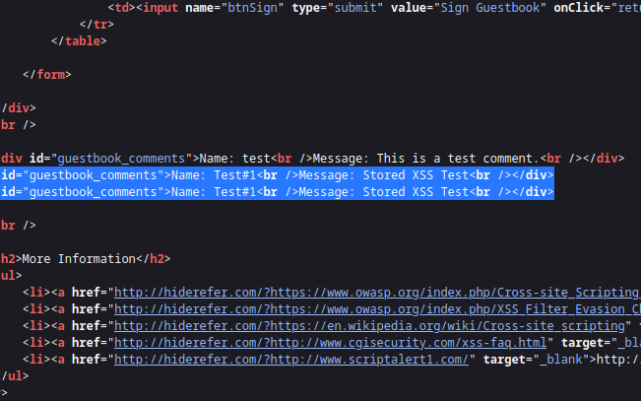

Both Test#1 and XSS Test should be in the page source code indicating that the two input fields may be vulnerable to a Stored XSS attack.
- Close the page source code tab and return to the Vulnerability page.

- Enter Test#1 in the Name * box and enter the following payload in the Message * box and click Sign Guestbook.
<ScRipt>alert("You are hacked!")</ScRipt>
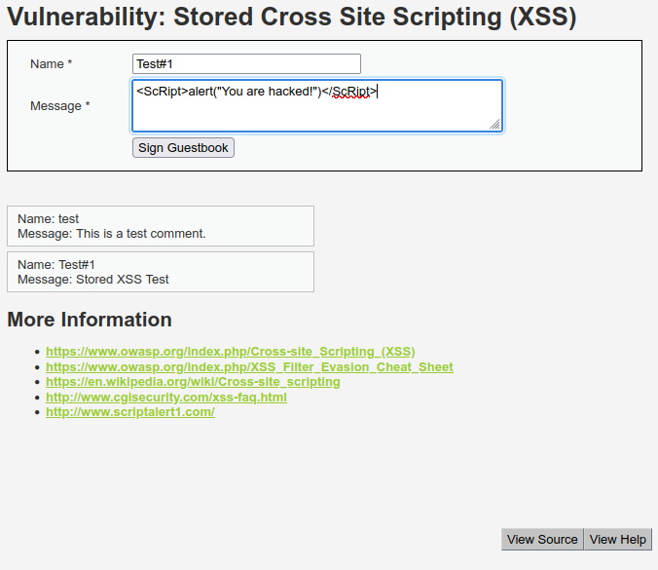

No popup box appeared. Refreshing the page not caused the alert popup box to appear either.
This means that there is code in the site backend that is sanitizing the user input from the Message * field.
- Click the View Source button and review the PHP source code and investigate.
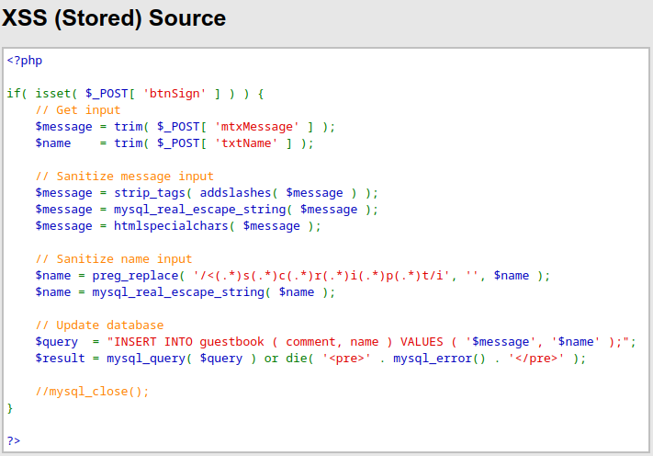

As before with the Medium security, the first block of code, under // Sanitize message input, contains two php functions for performing input sanitization. The strip_tags() function removes all html tags from the message field before storing them in the database. The htmlspecialchars() function converts all special characters into equivalent HTML characters so they are not reflected back in the browser.
The second block of code, under // Sanitize name input, is performing input sanitation on the Name * field. It contains the preg_replace() function. This function uses a regular expression to replace any occurrence of the <script> tag, regardless of character case, with a null value.
We can attempt to bypass the security on the Name * field by using some other payload that does not contain <script> tags.
- Before entering any payload into the Name * field, it will be necessary to change the max character length restriction on the field, as was done above.
With the maxlength restriction changed, the XSS payload can now be entered into the Name * field.
- Return to the Vulnerability page and enter the following payload in the Name * field. (Note the use of underscores to replace spaces.)
<svg onload=alert("You_are_hacked!")>
- In the Message * field, you can type any text you like and then click Sign Guestbook.
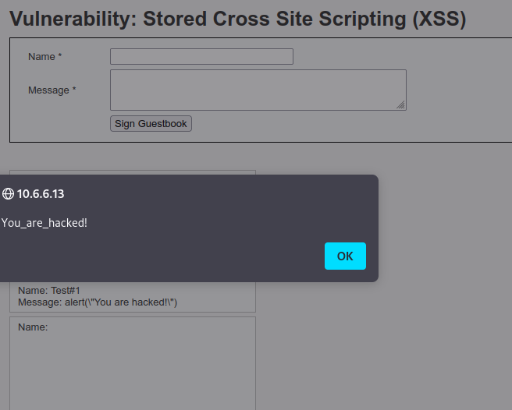

An XSS alert popup box will appear with the message "You_are_hacked!".
Because the XSS payload is stored in the guestbook, the alert popup box will appear each time the page is refreshed.
The popup confirms you have successfully exploited a Stored XSS vulnerability at High security level.
- Before proceeding to the next step, clear the XSS payload from the page. Click Setup / Reset DB in the left menu then click Create / Reset Database.
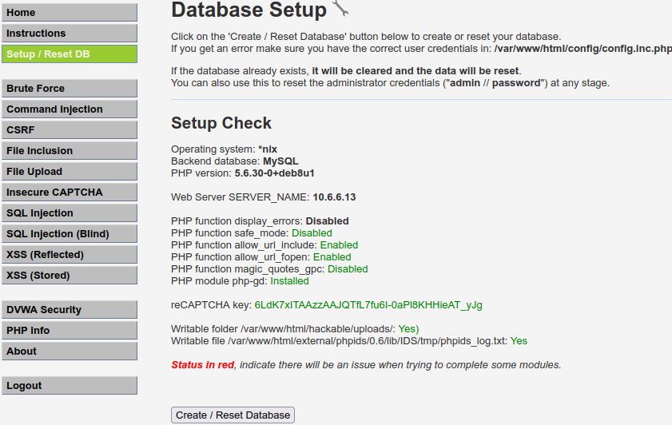

Step 4: Perform a stored iframe exploit.
- Select DVWA Security in the left menu and select Low in the Security Level dropdown. Click Submit.
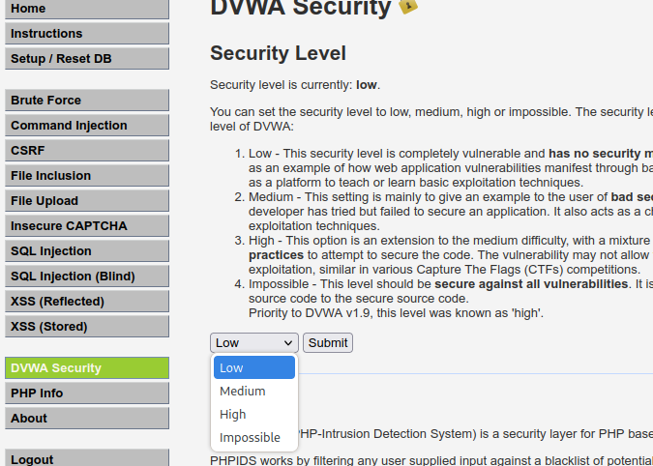

- Select XSS (Stored) in the left menu.

- Type the string iframe in the Name* field and type the following message in the Message * field. click Sign Guestbook.
<iframe src="http://h4cker.org"></iframe>
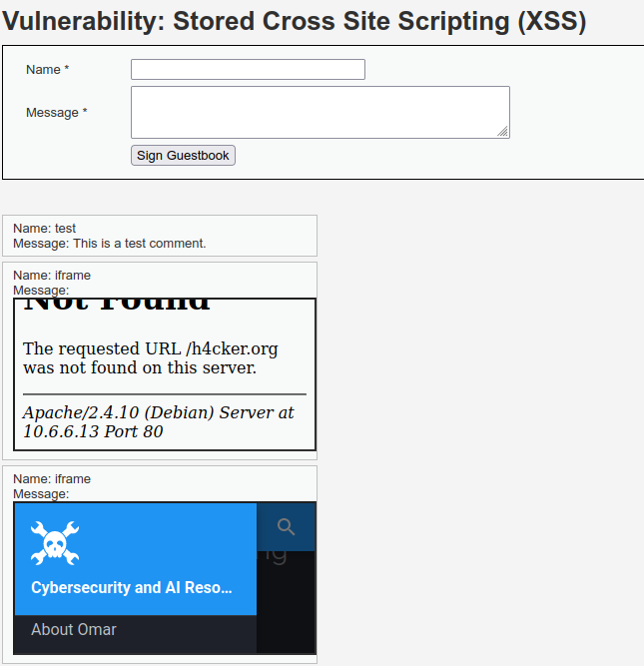

The H4cker website should now be displayed under the iframe test message.
- This is a powerful exploit because the threat actor could send the browser to a malicious website.
- Before proceeding to the next step, clear the XSS payload from the page. Click Setup / Reset DB in the left menu then click Create / Reset Database


Step 5: Perform a stored cookie exploit.

Stealing the cookies of website visitors has security implications. Cookies contain information about how and when users visit a web site and sometimes authentication information, such as usernames and passwords. Without proper security measures, a threat actor can capture cookies and use them to impersonate specific users and gain access to their information and accounts.
- Select DVWA Security in the left menu and select Low in the Security Level options dropdown. Click Submit.


- Select XSS (Stored) in the left menu.
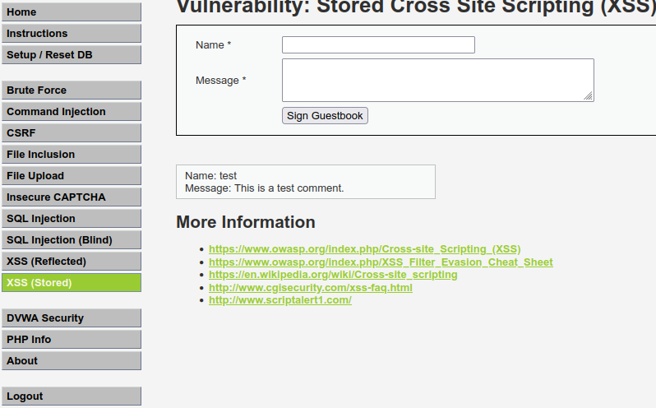

- Type the string cookie in the Name* field and type the following message in the Message * field. click Sign Guestbook.
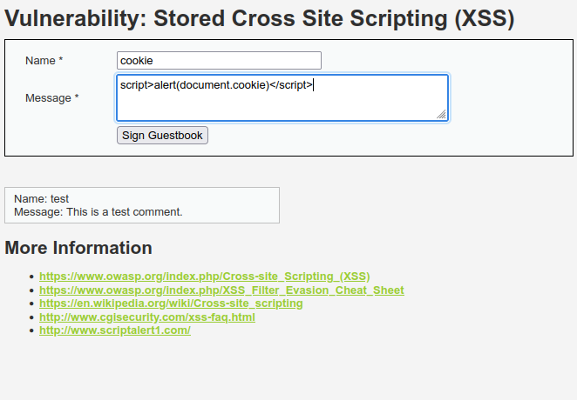
<script>alert(document.cookie)</script>

A popup box with the cookie will be presented. This is a cookie that PHP uses to keep of track of running sessions.
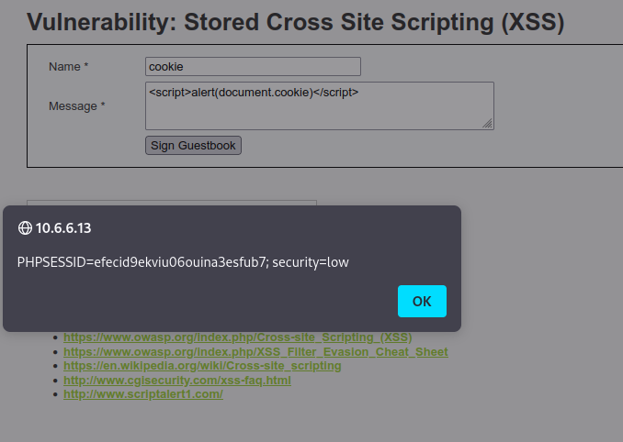

- Click OK in the pop-up box.

